Classroom Counseling Lesson Plan
Lesson Title | Grade Range | Time Needed
The Career Deck | K-2 | 20-30 minutes

Domain | Mindset Standards | Behavior Standards
Career | 3, 5 | LS 1,2 SMS 5 SS 3

Learning Objectives:
- Students will explore various career options by identifying tasks and tools that different workers may employ.
Supplies/Materials:
- The Career Deck (images and words of different careers attached to index cards or something similar- to prolong use it is recommended to laminate the cards)
Outline:
Note:There are several different activities that can be done using the Career Deck, based on the age and ability level of a class.
Career Charades- Have students look at a card and act out a person of that career at work. Provide clues and cues to both the student acting as well as the class as a whole. Ask students why they think that is the job being acted out (i.e. “Why do you think he is a firefighter?”, “What kind of a tool was she using that told you they were a carpenter”). Determine which student goes next and repeat.
I Need Someone Who…- Pass out one card to each student. Allow them the opportunity to read their card and help them in understanding which career they have, as needed. Tell the class that you are in need of help from a variety of people. Have students raise their hand if they think they have a career that matches what you are looking for. You may wish to prepare a list a head of time of prompts. Examples include: “I need someone who works with sharp tools.”, “I need someone who spends most of their time outside.”, “I need someone who I would call if I were getting married.” Call on students who raise their hand and have them explain why they think they match. Affirm their response if it is accurate or encourage them to keep trying. You may want to use three of four prompts that allow for all students to contribute at least once. If time allows, collect cards and pass them out so that students have a different card.
Guess My Career- Tell the class that you are going to give them clues to a certain career and they must work as a team to guess which career you are describing. Pull a card off the top of the stack and (similar to I Need Someone Who) give them a clue about that career (i.e. “This person has a job that is dangerous.”, “This person has to travel a lot for their career.”). Affirm their answer as correct or discuss why that answer could work but does not match what is on the card. Give additional clues as necessary.
-Variation #1- Follow as above. This time, tell them that they have a set number of clues and a set number of guesses per clue (3 clues, with 3 guesses each). Each time they guess correctly within the number of guesses, the card goes into a “completed” pile. If they do not guess correctly within the set number of guesses, reveal the career, explain as necessary, and place in a “didn’t get it” pile. After explaining the rules, help the class set a goal to see how many they can successfully complete before time is up.
-Variation #2- This version is more competitive. Divide the class into teams. Each team takes turn to guess the career. Draw a card (or use a pre-made list) to give a clue about a career. If they can guess correctly after the first clue, then earn 10 points. If they do not guess correctly, they get a second clue. A correct answer now is only worth 5 points. If the team is still not correct, they get one additional clue. A correct answer is 2 points. At the end of play, the team with the most points wins.

Zookeeper

Veterinarian

Police Officer

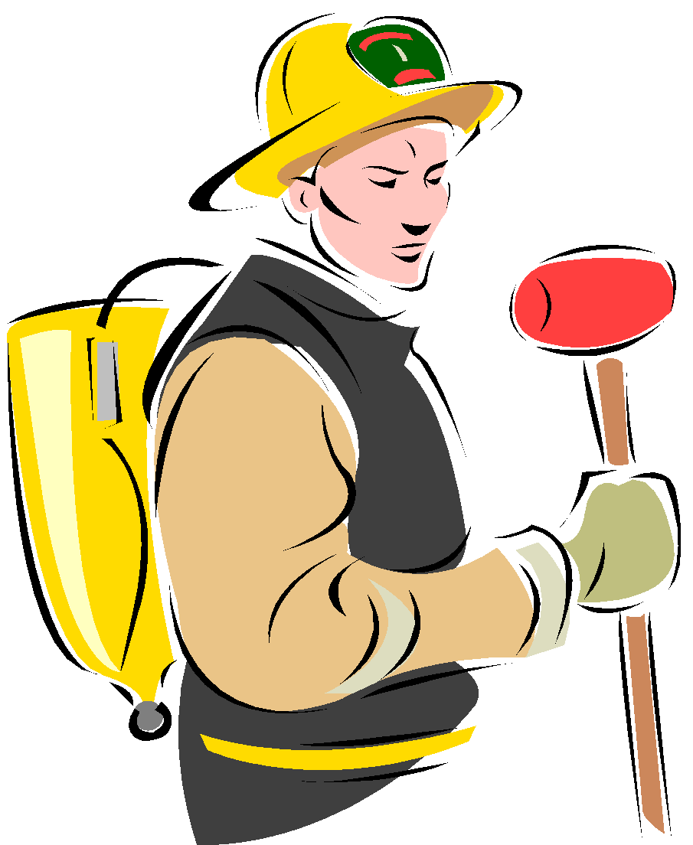 Fire Fighter

Store Clerk

Doctor

Nurse

Plumber

Auto Mechanic

Teacher

Principal

Carpenter

Chef

Librarian

Scientist

Astronaut

President

Senator

Solider

Actor

Reporter

Dentist

Farmer

Musician

Judge

Pharmacist

Pilot

Postal Worker

Hair Stylist

Electrician

Janitor/Custodian

Lumberjack

Architect

Photographer

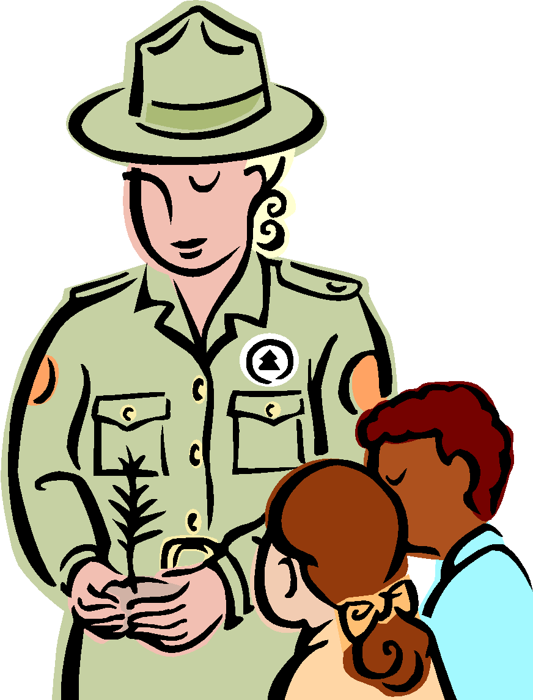 Forrest Ranger
Artist

Author

Athlete

Garbage Collector

Rancher

Accountant

Server

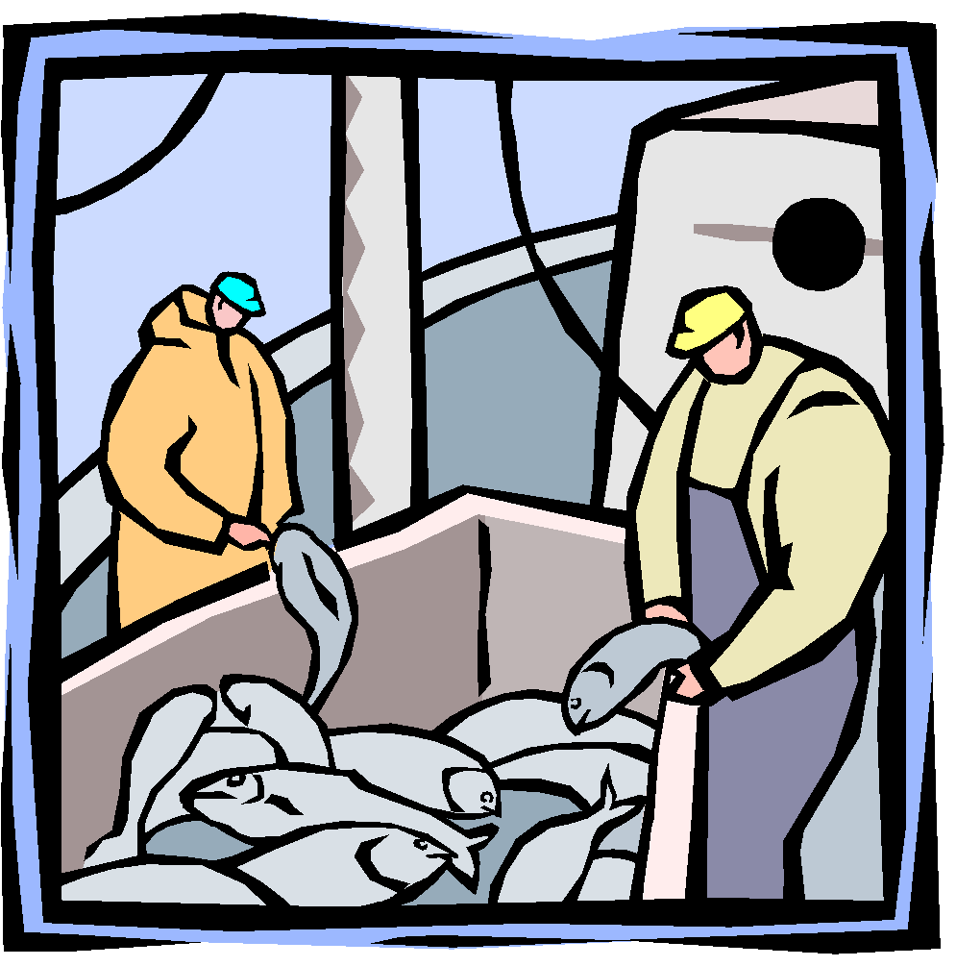 Fisherman

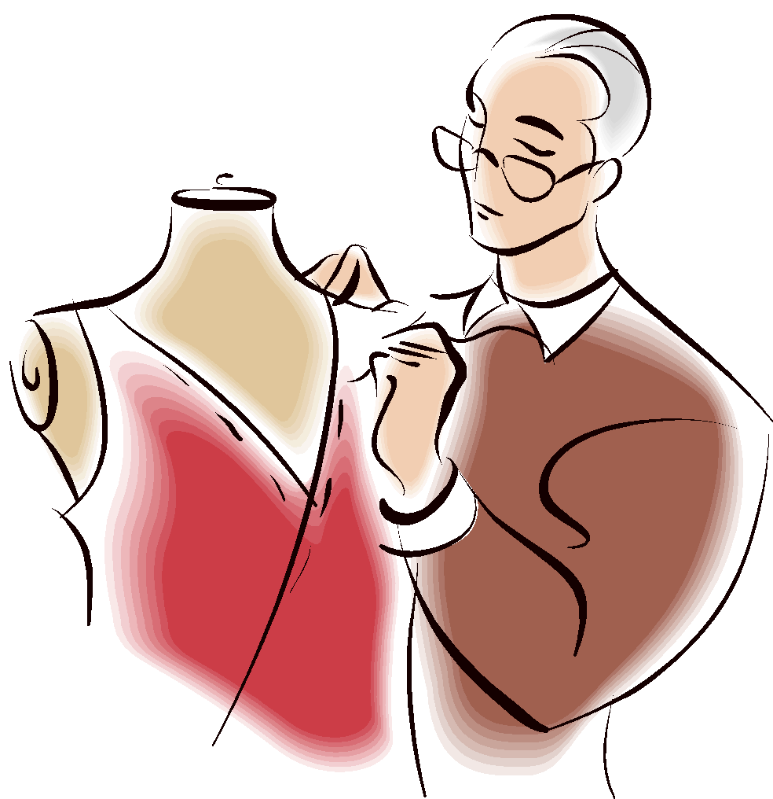 Clothing Designer

Fashion Model

Butcher

Road Worker

Lifeguard

Journalist

Florist

