Classroom Counseling Lesson Plan
Lesson Title | Grade Range | Time Needed
Career Pizza | 6-8 | 20-30 minutes

Domain | Mindset Standards | Behavior Standards
Career | MS3 | LS1, LS2, SMS5, SS4, SS6, SS7, SS9

Learning Objectives:
Students will be able to:
- Identify careers from a variety of career clusters.
- Recognize a variety of career options are available in one field.
Supplies/Materials:
- One piece of paper per group, one writing utensil per group, picture of a pizza
Outline:
- Counselor should begin by introducing careers and stating they will be having a class competition.
- Break students into groups of 3-5 students.
- Show students a picture of a pizza.
- Explain that as a group the students need to come up with as many careers that relate to this pizza as possible.
  - Counselor may want to link pizza to a fast food chain.
- Encourage students to be creative, but explain they must have an explanation for each career.
  - Examples:
    - Farmer – grows vegetables
    - Manager – oversees people who work at the fast food pizza chain
- Give students a specific amount of time to come up with their career lists.
- Go through each group’s list.
  - If a group has the same career listed as another group both groups need to cross it off.
  - Group with the most careers left wins.
- Counselor should end lesson by discussing how each career cluster fits into a variety of jobs/career paths.

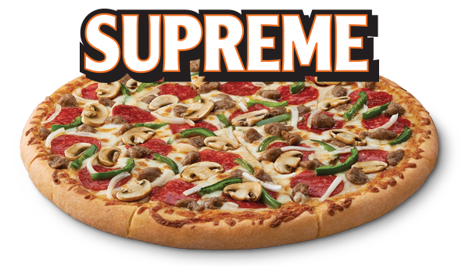
Please use the space below to list as many careers as you can that relate to this pizza. Be prepared to explain how each career relates.

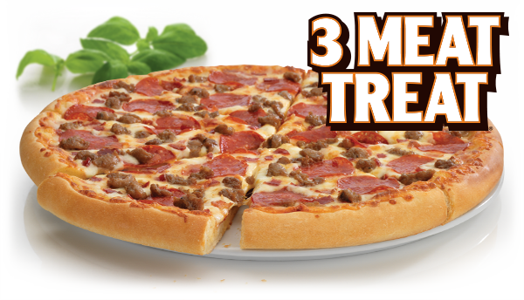
Please use the space below to list as many careers as you can that relate to this pizza. Be prepared to explain how each career relates.

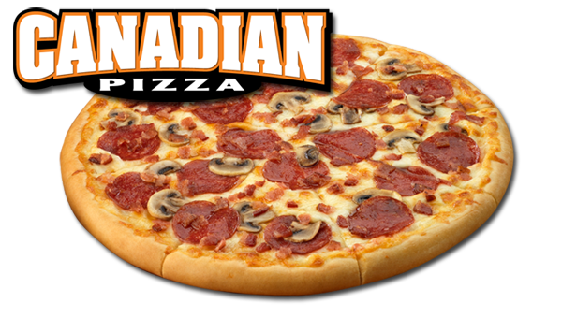
Please use the space below to list as many careers as you can that relate to this pizza. Be prepared to explain how each career relates.

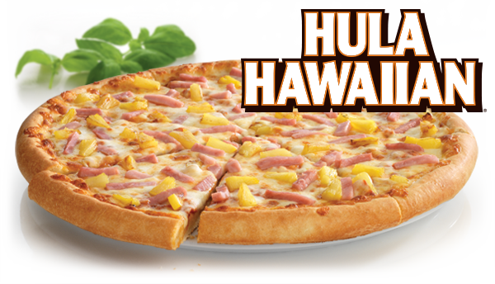
Please use the space below to list as many careers as you can that relate to this pizza. Be prepared to explain how each career relates.

Please use the space below to list as many careers as you can that relate to this pizza. Be prepared to explain how each career relates.

