Classroom Counseling Lesson Plan
Lesson Title | Grade Range | Time Needed
My Career Packet | K-2 | 30-40 minutes

Domain | Mindset Standards | Behavior Standards
Career | 1, 4, 5 | LS 1,2 SMS 1,3,5,6,7,8, 9 SS 4,5,7,8,9

Learning Objectives:
- Students will learn about different tools that workers can use; strategies for successfully working with other people; and why people choose the careers they do.
- Students will contribute ideas and share experiences with the group.
Supplies/Materials:
- Copies of the Career Packet (attached)
Outline:
- Students receive a copy of the packet.
- The instructor will introduce each section of the packet. Students will then be given time to write responses.
- The instructor will lead a discussion and moderate students sharing their responses.
- Adjust materials based on age, ability level, or time. For younger students, it may be recommended to project visuals on a Smartboard or similar device.
Sample discussion questions:
“What can a farmer do with [tool the student listed]?”
“How does that tool help you as a student?”
“What happens when people don’t get along? Can it affect how much work gets done?”

My Career Packet Name: _________________________

Part 1- Tools
Students just like any other workers need tools to help them do a good job. Without a stove, a chef/cook could not make ___________________________________________.

Dentists need _______________________________________.

Farmers need ________________________________________
and _________________________________________________.

If a carpenter were going to build a bookcase they would probably need ______________________________________ and _________________________________________________.
To be a student, I also need tools to help me do my job. Some of my tools are:
______________________ ______________________
______________________ ______________________
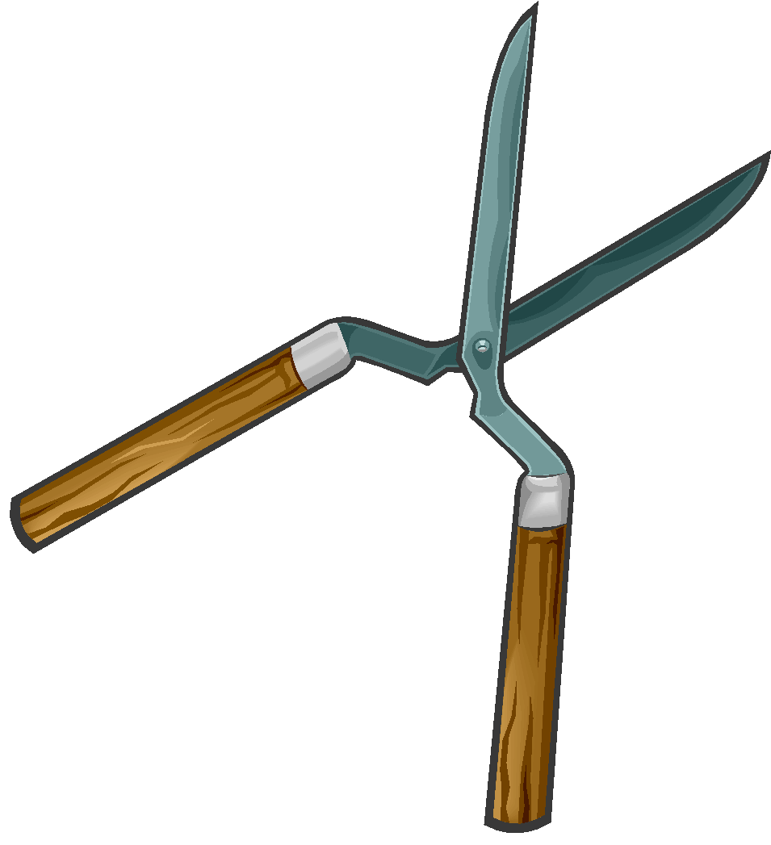

Part 2- Getting Along with Others

For my job to go smoothly, I need to get along with all the other students and grownups who work with me. Getting along with others means:

______________________________________________________

______________________________________________________

It’s easy to get along with others, if you do these things:

______________________ ______________________

______________________ ______________________

______________________ ______________________

Part 3- Why Work?

Everyone knows that people usually get some sort of reward for working. Most people get paid money for their time and skills provided. What are some other reasons why people may choose to do the jobs they do?

Teacher: ______________________ ______________________

Doctor: ______________________ ______________________

Principal: ______________________ ______________________

Police Officer: ___________________ ______________________

Scientist: ______________________ ______________________

Astronaut: _____________________ ______________________

Part 3.5- Your Work

What is a job you would like to have someday and why would you want to do it?

______________________________________________________

______________________________________________________

Part 4- Find the Helpers

Draw a line to connect the worker on the left, with someone who may need his or her help on the right.

