Classroom Counseling Lesson Plan
Lesson Title | Grade Range | Time Needed
My Job as a Student - Part 1 | K-2 | 20-30 minutes

Domain | Mindset Standards | Behavior Standards
Career/Academic/ES | 1, 2, 3, 5 | LS: 3, 6; SM: 1, 2, 9; SS: 5

Learning Objectives:
- Understand my job is being a student
- Identify duties I perform as a student

Supplies/Materials:
- Occupations printouts
- Duty cards (cut out individually)

Outline:
- State: Everyone has a job to do. Does anyone know what your parents do for their job?
- Have some students share what their parents do.
- Hold up job print outs one at a time ask: What is this person’s job? What does a _________ do? Point out that men and women can do any job.
- Ask student what their job is?
- Explain that school is like their job. Just like a teacher does certain things in her/his job, students have jobs they need to do also.
- Play Thumbs up Thumbs down activity with duty cards.
- Give out cards to students and have them come to the front one at a time. Read their card and if it is something a good student would do they give thumbs up sign, if bad student would do it, they give thumbs down sign. (if an active class you can ask them to show you what the positive activities look like).
- Review some of the things that good students do and encourage them to be good students by doing those things.

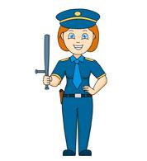

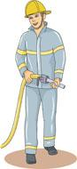

Duty Cards
I sit still

I listen to the teacher

I talk when the teacher is talking

I treat my classmates nice

I help others

I laugh at others when they make mistakes

I talk to my neighbor

I run in the hallway

I play around in the bathroom

I go to bathroom, wash my hands and come right out

I play with everyone

I don’t let others play

I raise my hand to talk

I talk out of turn

I don’t take turns
I take turns and share

I do my work, until it is done

I look around the room and do not do my work

I follow the classroom rules

I tell the truth

I go to bed on time

