Classroom Counseling Lesson Plan
Lesson Title | Grade Range | Time Needed
My Job as a Student- Part 2 | K-2 | 20-30 minutes

Domain | Mindset Standards | Behavior Standards
Career/Academic/ES | 1, 2, 3, 5 | LS: 3, 6; SM: 1, 2, 9; SS: 5

Learning Objectives:
- Understand my job is being a student
- Identify duties I perform as a student
Supplies/Materials:
- Social Story
- Camera Optional
- Photo Story Plan (optional)

Outline:
- Review last week
- Ask if anyone else wants to share what their parents do for a job.
- Hand out social story: and tell students you will be reading it today.
- Read through the story
- Discuss the story
- Have students draw pictures on the cover of the book about being a good student.
- End by asking them to practice being a good student every day.
Use Technology Variation or Addition to lesson:
- Play a previous year’s photos story…
- Bring in a pre-planned photos story that you need their help to finish
- Take photos to put together in a photo story… Kids can draw while you do this
- Can divide the class so everyone can be in one of the photos

My Job As A Student

By:_______________

It is a student’s Job to:
1. Listen to the teacher
2. Raise your hand
3. Wait quietly for your turn
4. Sit at your seat (with your chair on the floor)
5. Do what the teacher tells you to do right away
6. Work quietly at your seat
7. Don’t do things that distract others
8. Do things to get good attention
a. Get your work done
b. Sit quietly
c. Work hard
d. Be nice to others
9. Go to bed early, so you are not tired for school
10. Keep your hands and feet to yourself
11. Be honest and tell the truth

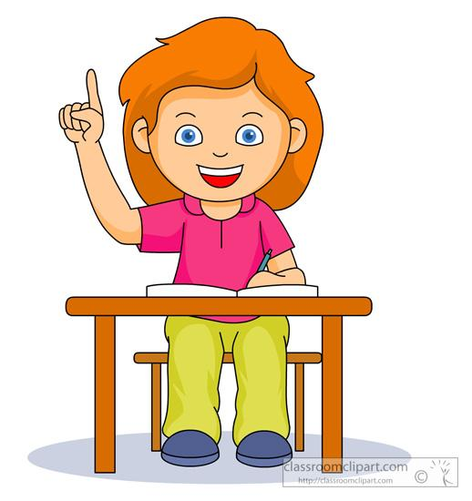

Every day in School I wait at my seat quietly. Then sometimes it is my turn to talk. If I want to answer a question I raise my hand and the teacher calls on me.
I do not talk unless the teacher calls on me. I do not talk to people next to me when my teacher is talking to the class.

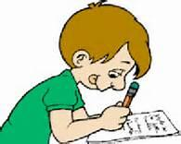

We learn lots of new things in school. Sometimes we do things in class that I don’t want to do. I do it anyway because it is my job as a student to do my work. I do my work without pouting or saying I don’t want to. Other kids don’t like it when classmates pout and don’t do their work.

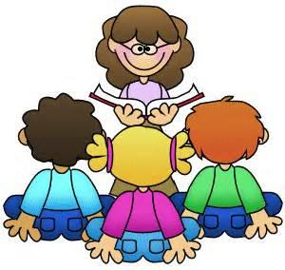

In school I have class with many different teachers. I listen to every teacher. I sit at my seat with all four legs of my chair on the floor and listen.
I listen by looking at the teacher, not talking or making other noises, and sitting still. Other kids cannot listen if I make noises when the teacher is talking. What the teachers have to say is important and everyone should be able to hear it.

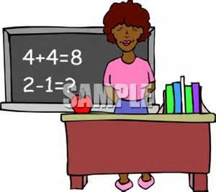
Sometimes in School I want the teacher to give me some attention. I need to get good attention from the teacher. I can get good attention by doing my work right, sitting in my seat quietly, not distracting others, working hard, being nice to others and by following the rules in my classroom.

I do not want to get bad attention from the teacher, because then I will get into trouble at school. When I get into trouble at school, I also get into trouble at home. My parents like me to get good attention not bad attention from my teacher.

Each night I will go to bed on time. I will listen to my parents when they say it is bedtime. When I get a good night’s sleep it is easier for me to learn at school. It is easier getting up in the morning when I go to bed on time. When I am not tired I have a good day and I am ready to learn. Learning is a very important part of school.

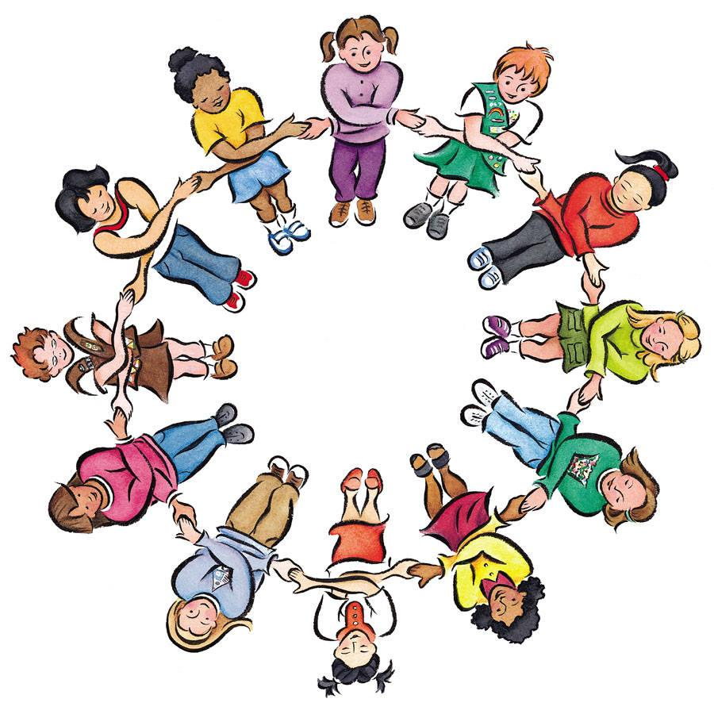
At school I am nice to my classmates. I share toys with them. I play with everyone on the playground. I keep my hands and feet to myself, so that I do not hurt one of my classmates.
I say only nice things to my classmates, because mean words can hurt other kid’s feelings.
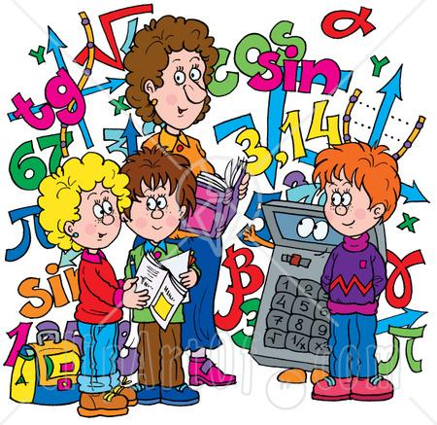
It is important to tell the truth in school. Sometimes it is scary to tell the truth, because I think I will get into trouble. I need to remember that I will get into more trouble if I lie.
Teachers usually find out the truth and when they do, kids who lie, get into trouble. This is why I should always tell the truth right away.

The truth gets me out of trouble and lies get me into trouble. My teacher is proud of me if I tell the truth because she know how hard it can be to do. I love to have my teacher be proud of me.

I will work hard to be a good student in school. I will do all the things I’ve learn about in this book. If I am a good student the teachers will be proud of me. My parents will also be proud of me. I will also be proud of myself. It is great to be proud of yourself.

