Classroom Counseling Lesson Plan
Lesson Title | Grade Range | Time Needed
The Monster, the Mouse and Me | 3-5 | 30 minutes

Domain | Mindset Standards | Behavior Standards
Career/ES | 1 | LS: 1, 5, 9 SM: 1, 5, 8 SS: 1, 2, 3 6, 7, 9

Learning Objectives:
- Students will learn what it means to be assertive
- Students will recognize what assertive looks like
- Students will practice being assertive
Supplies/Materials:
- Monster, Mouse and Me Handout
- Role plays

Outline:
- Ask students if they know what it means to be assertive (standing up for yourself, without putting someone else down)
- Write on the board three headings… Monster, Mouse, and Me
- Ask students to think about a monster.. What are they like? (loud, aggressive, in your face, invade your personal space)
- Ask students to think of a mouse….. What is a mouse like? (quiet, can get stepped on, doesn’t say anything)
- Explain that they don’t want to be aggressive like the monster or passive like a mouse but they want to be assertive
- Under the heading me write the characteristics of assertive (see handout)
- Provide students with the handout, discuss (they will do the questions at the end of the lesson)
- Activity:
  - Have one volunteer come to the front of the room at a time to help
  - Provide the person with the response
  - The class will decide if the response are being passive, aggressive or assertive
  - If the response isn’t assertive they class with try to come up with an assertive response (they may need some help)
  - You may want to discuss in the workplace what the difference between being passive and customer service might look like.
- Have students complete the Taking a closer look at myself worksheet, discuss.
Role Play Situations and Responses
Sample 1: You are at work and your coworker comes up to you and says:
Counselor: “I cannot believe you put the paper towel role on the holder the wrong way again. Seriously, I don’t know how many times we have talked about how it works better the other way. Did you leave your brain at home today?”
You respond:
Volunteer: “Really man!!! Don’t you think there are more important things to worry about than those paper towels!!” “Who died and made you the boss around here anyway.” I don’t have to take orders from you!!!” (be loud and invade the coworkers space).
Is this passive, assertive or aggressive?

Sample 2: You are working in a grocery store and a customer says:
Counselor: “Hey you, kid.” “Where did they move the apple sauce?” “Did you know the last three times I was in here it has been in a different place, what do you think I want to spend all day looking for one item or what?”
You respond:
Volunteer: “Sorry, it has been a hassle for you but I do know right where the apple sauce is, let me show you. (Make sure to look the other person in the eye, and have a cheerful tone of voice)
Is this passive, aggressive, or assertive??

Sample 3: You are working on a group project and your partner is not doing his/her share of the work so you say…
Volunteer “This project is due on Friday how far are you on your part?”
Counselor: “It’s going to be easy, don’t worry I will get it done.”
Volunteer: “Yeah, ok.”(In a soft voice, looking down)
Is this passive, aggressive or assertive?

The Mouse

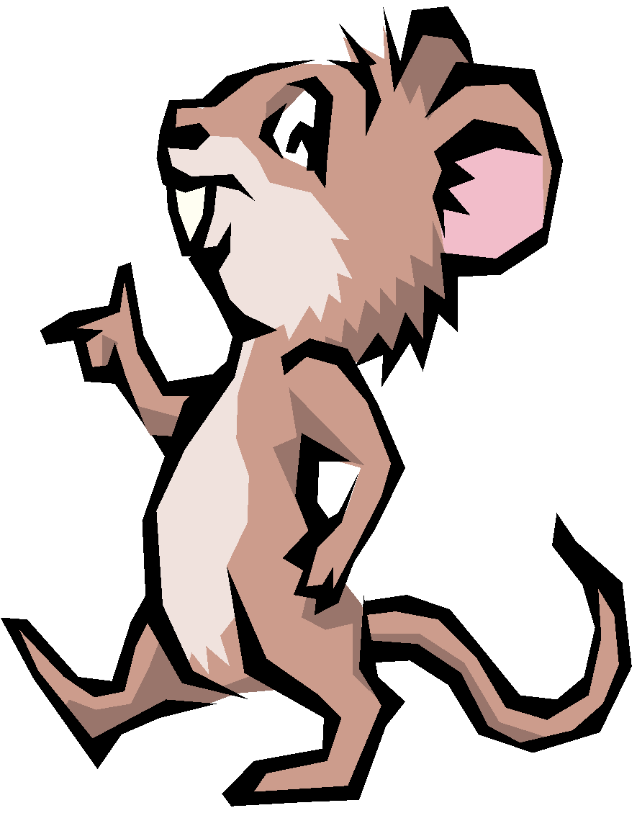
- A mouse appears: Shy, timid or afraid
- Mice are often very nice
- They often get walked on by other people, because they cannot speak up for their rights
- Sometimes a mouse can get squashed
- Sometimes mice worry too much about what other people think of them
- Mice are also very accommodating and often do whatever others want them to do

The Monster
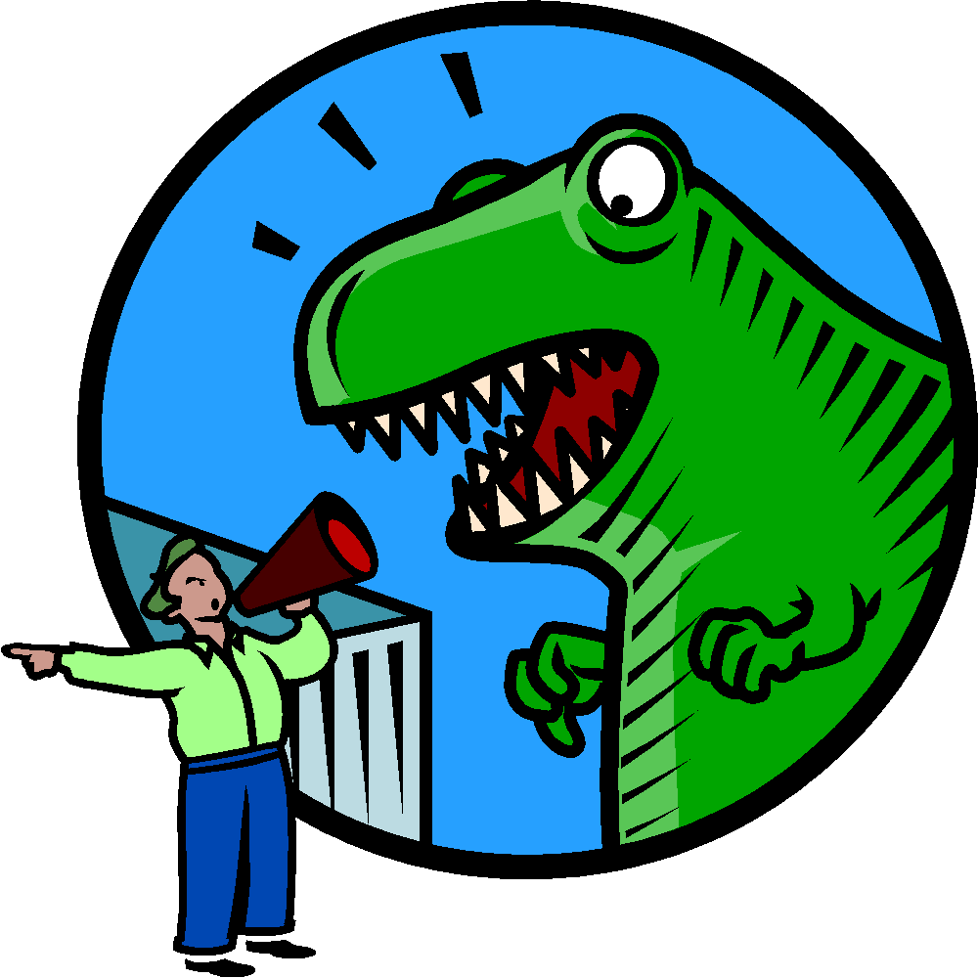
- A monster is loud, boss, and pushy
- A monster dominates and intimidates others
- They don’t pay attention to other’s rights
- A monster often “steps” on others
- They react instantly, often without thinking
- A monster may get very angry when he/she doesn’t get what she/he wants
- They often invade other’s personal space

Me
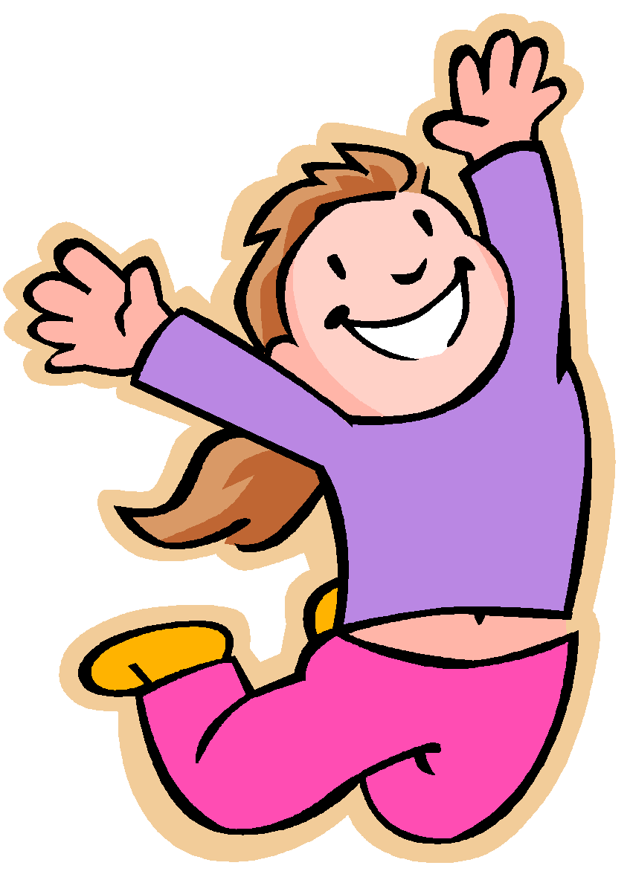

- I am firm, direct and honest
- I respect the rights of others
- I also don’t let other’s “step” on me or disrespect my rights
- I speak clear and to the point, I don’t say hurtful things that don’t need to be said
- I’m confident about who I am
- I know that I have choices about my life
- I don’t put others down to make myself feel better

My Rights:

These are my rights as a human being and should not be taken away by anyone else. I will remember these rights are mine and they are also everyone else’s right as well.

I have the right to:

- say “No”

- be confident and proud of my accomplishment

- say “I don’t know, I don’t agree, and I don’t understand”

- be treated with respect

- express my needs, opinions thoughts, ideas and feelings

- recognize my needs are important

- feel and express anger (appropriately)

- have a support system

- to feel safe in my environment

Taking a look at myself

- Most of the time am I a mouse, a monster or me?

- Think about a time you were a mouse. What did you lose from being a mouse instead of being me?

- Think about a time you were a monster. What did you lose from being a monster instead of me?

- Do you think people always know that they are being a mouse or a monster? Why or why not?

- What are you going to do to be me more often?

